Face_cnn_keras
功能：

环境：
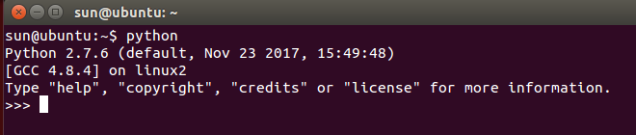
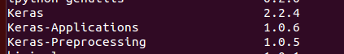

源数据：
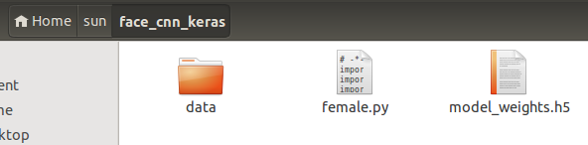
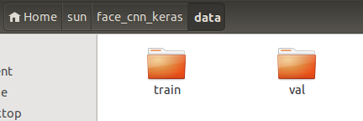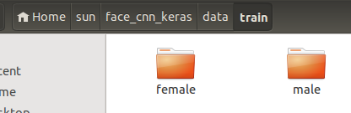

代码分析：
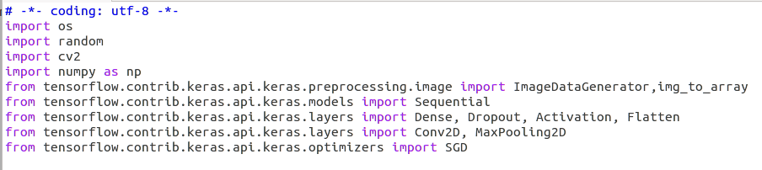

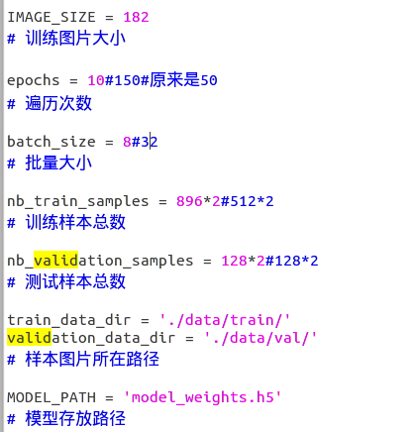
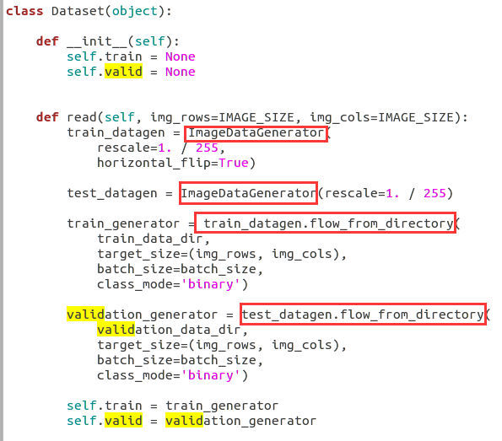
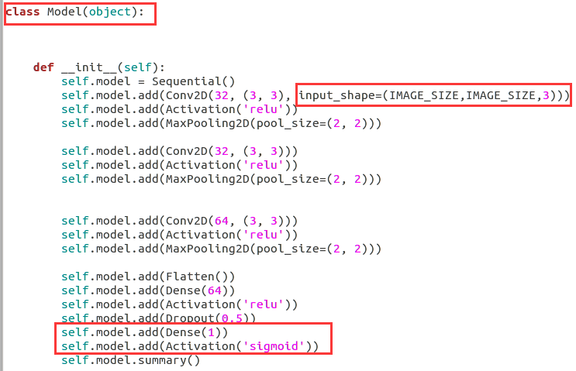
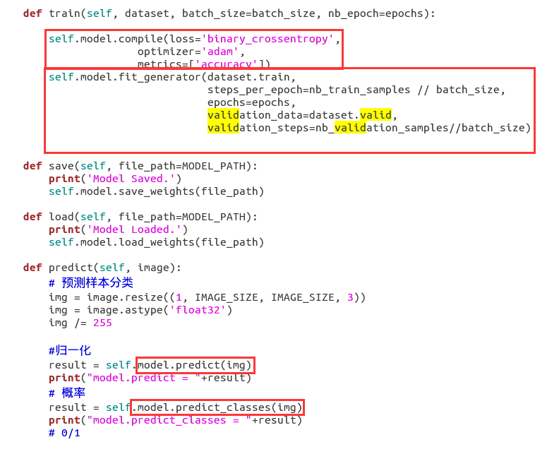
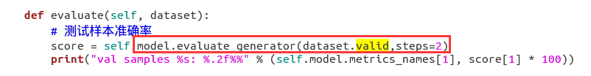
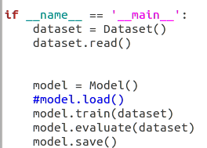

代码运行：
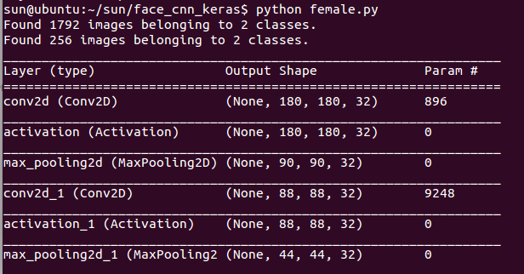
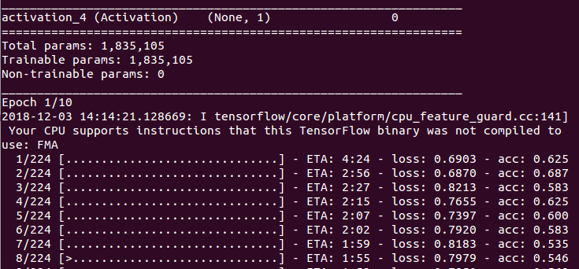
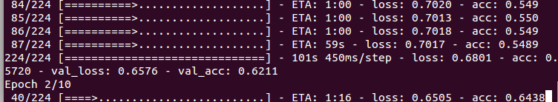

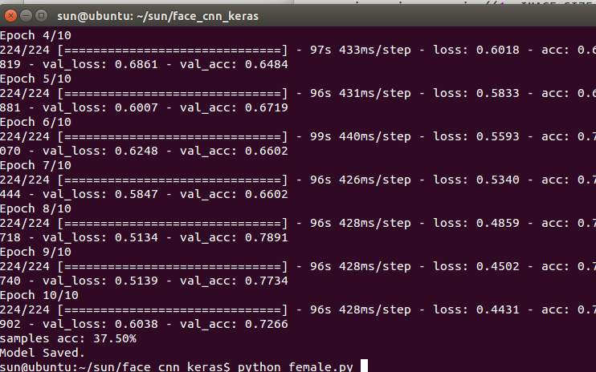

以上为训练

下面为验证集评估
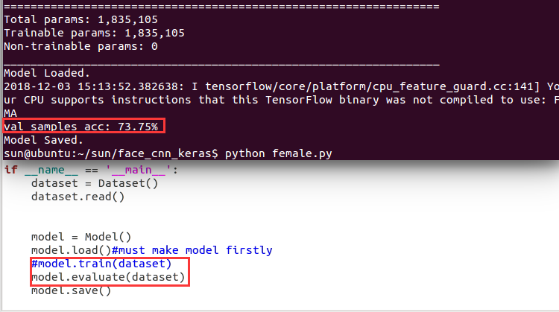

下面为图像预测
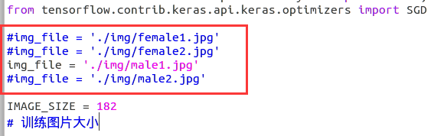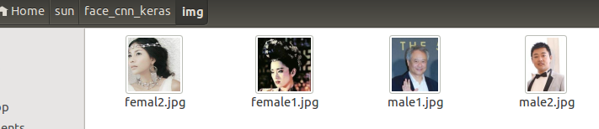
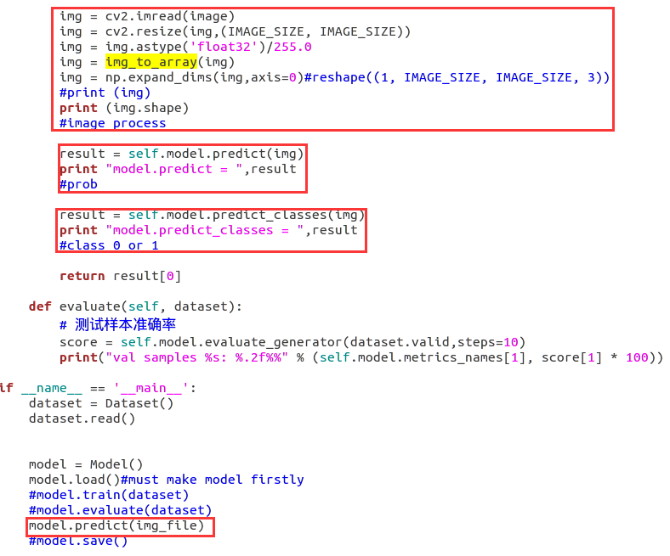
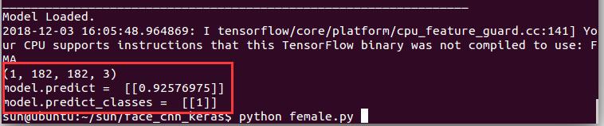
0 is female; 1 is male

问题1：
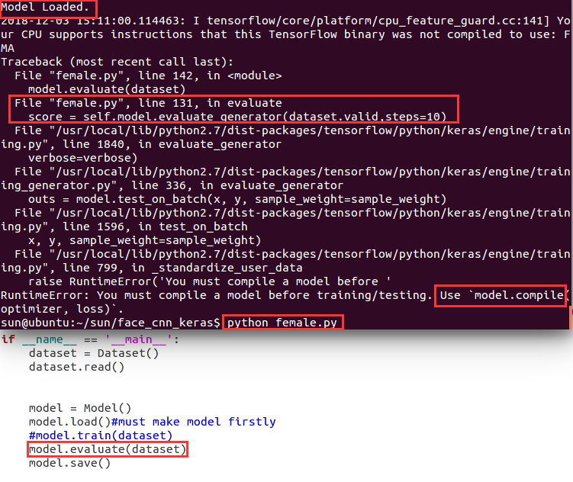
解决：
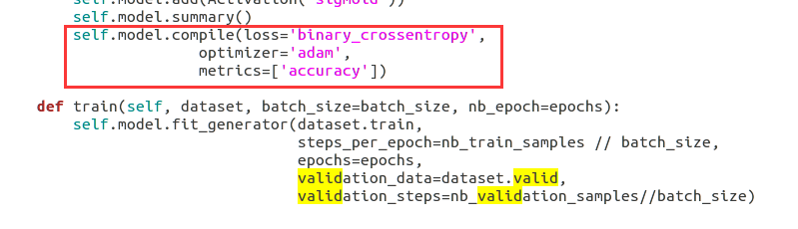
更换compile位置即可，放在model之后，fit_generator之前。

问题2：
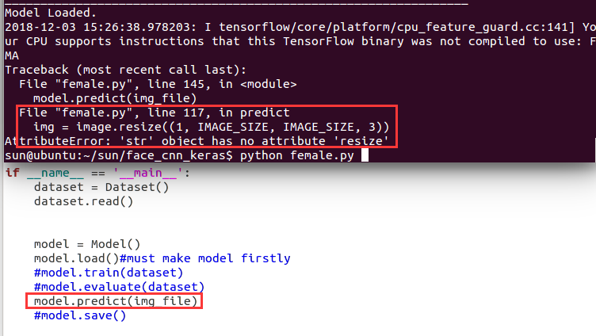
解决：
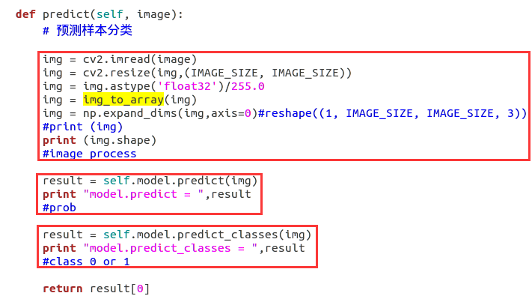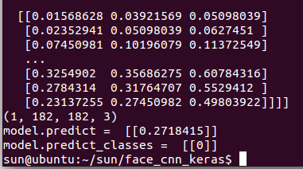
参考：
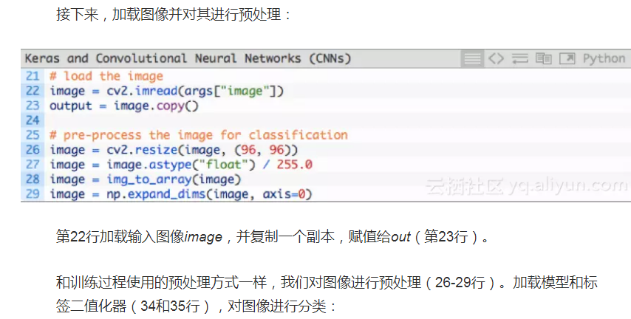

参考2：
https://keras-cn.readthedocs.io/en/latest/models/sequential/
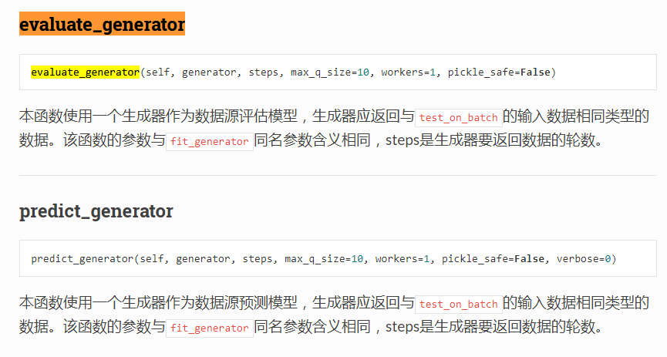
参考1：
http://www.cnblogs.com/ansang/p/8583304.html

keras实现简单性别识别（二分类问题）

完全版
import osimport randomimport cv2import numpy as npfrom tensorflow.contrib.keras.api.keras.preprocessing.image import ImageDataGenerator,img_to_arrayfrom tensorflow.contrib.keras.api.keras.models import Sequentialfrom tensorflow.contrib.keras.api.keras.layers import Dense, Dropout, Activation, Flattenfrom tensorflow.contrib.keras.api.keras.layers import Conv2D, MaxPooling2Dfrom tensorflow.contrib.keras.api.keras.optimizers import SGD

IMAGE_SIZE = 182# 训练图片大小
epochs = 150#原来是50
# 遍历次数
batch_size = 32# 批量大小
nb_train_samples = 512*2# 训练样本总数
nb_validation_samples = 128*2# 测试样本总数
train_data_dir = 'D:\\code\\learn\\data_sex\\train_data\\'
validation_data_dir = 'D:\\data_sex\\test_data\\'# 样本图片所在路径
FILE_PATH = 'Gender_new.h5'# 模型存放路径class Dataset(object):

def __init__(self):
self.train = None
self.valid = None

def read(self, img_rows=IMAGE_SIZE, img_cols=IMAGE_SIZE):
train_datagen = ImageDataGenerator(
rescale=1. / 255,
horizontal_flip=True)

test_datagen = ImageDataGenerator(rescale=1. / 255)

train_generator = train_datagen.flow_from_directory(
train_data_dir,
target_size=(img_rows, img_cols),
batch_size=batch_size,
class_mode='binary')

validation_generator = test_datagen.flow_from_directory(
validation_data_dir,
target_size=(img_rows, img_cols),
batch_size=batch_size,
class_mode='binary')

self.train = train_generator
self.valid = validation_generator

class Model(object):

def __init__(self):
self.model = Sequential()
self.model.add(Conv2D(32, (3, 3), input_shape=(IMAGE_SIZE,IMAGE_SIZE,3)))
self.model.add(Activation('relu'))
self.model.add(MaxPooling2D(pool_size=(2, 2)))

self.model.add(Conv2D(32, (3, 3)))
self.model.add(Activation('relu'))
self.model.add(MaxPooling2D(pool_size=(2, 2)))

self.model.add(Conv2D(64, (3, 3)))
self.model.add(Activation('relu'))
self.model.add(MaxPooling2D(pool_size=(2, 2)))

self.model.add(Flatten())
self.model.add(Dense(64))
self.model.add(Activation('relu'))
self.model.add(Dropout(0.5))
self.model.add(Dense(1))
self.model.add(Activation('sigmoid'))

def train(self, dataset, batch_size=batch_size, nb_epoch=epochs):

self.model.compile(loss='binary_crossentropy',
optimizer='adam',
metrics=['accuracy'])
self.model.fit_generator(dataset.train,
steps_per_epoch=nb_train_samples // batch_size,
epochs=epochs,
validation_data=dataset.valid,
validation_steps=nb_validation_samples//batch_size)

def save(self, file_path=FILE_PATH):
print('Model Saved.')
self.model.save_weights(file_path)

def load(self, file_path=FILE_PATH):
print('Model Loaded.')
self.model.load_weights(file_path)

def predict(self, image):
# 预测样本分类
img = image.resize((1, IMAGE_SIZE, IMAGE_SIZE, 3))
img = image.astype('float32')
img /= 255

#归一化
result = self.model.predict(img)
print(result)
# 概率
result = self.model.predict_classes(img)
print(result)
# 0/1

return result[0]

def evaluate(self, dataset):
# 测试样本准确率
score = self.model.evaluate_generator(dataset.valid,steps=2)
print("样本准确率%s: %.2f%%" % (self.model.metrics_names[1], score[1] * 100))
if __name__ == '__main__':
dataset = Dataset()
dataset.read()

model = Model()
model.load()
model.train(dataset)
model.evaluate(dataset)
model.save()

